const int TRIG_PIN = 7 ; const int ECHO_PIN = 8;

const unsigned int MAX_DIST = 23200;

void setup() {

Mode(TRIG_PIN, OUTPUT);

digital Write(TRIG_PIN, LOW);

pinMode(ECHO_PIN, INPUT ) ;

Serial.begin(9600);

}

void loop() { unsigned long t1;

unsigned long t2;

unsigned long pulse_width; float cm;

float inches;

digitalWrite(TRIG_PIN, HIGH); delayMicroseconds(10); digitalWrite(TRIG_PIN, LOW);

while (digitalRead( ECHO_PIN )==0 );

t1= micros ();

while (digitalRead(ECHO_PIN) == 1); t2= micros ();

pulse_width = t2-t1;

cm=pulse_Width / 58 ;

inches = pulse_width/148.0;

if (pulse_width >MAX _ DIST ){ Serial.println("Out of range");

} else {

Serial.println("**************************”); Serial.print("The Measured Distance in cm: "); Serial.println(cm);

if( cm < 100 ){

while(true){

Serial.println(“Alert!!”);

}

}

Serial.print(“*********************************”);

}

Delay(1000);

}

**Output:**

# If the distance is less than 100 cms ,it alerts.

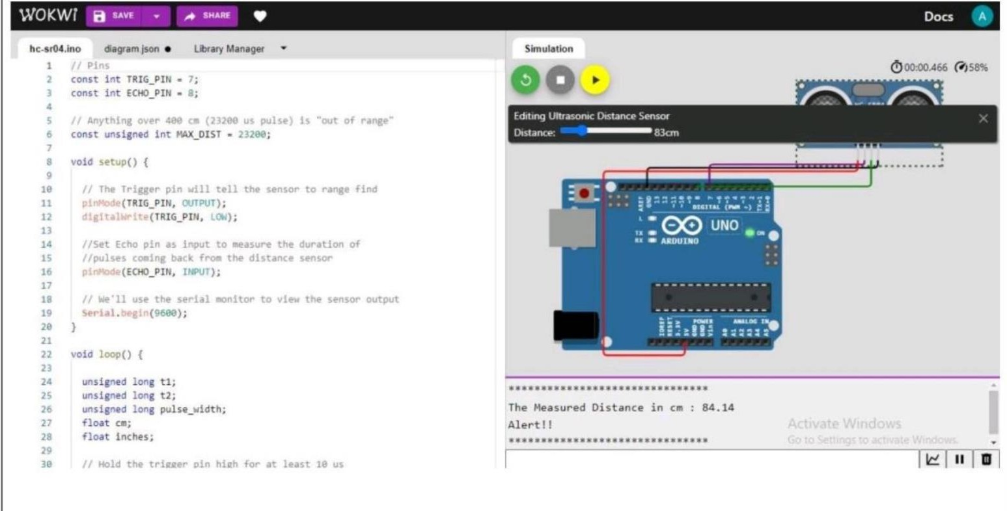

1. **If the distance is more than 100 cms,it won’t alert**

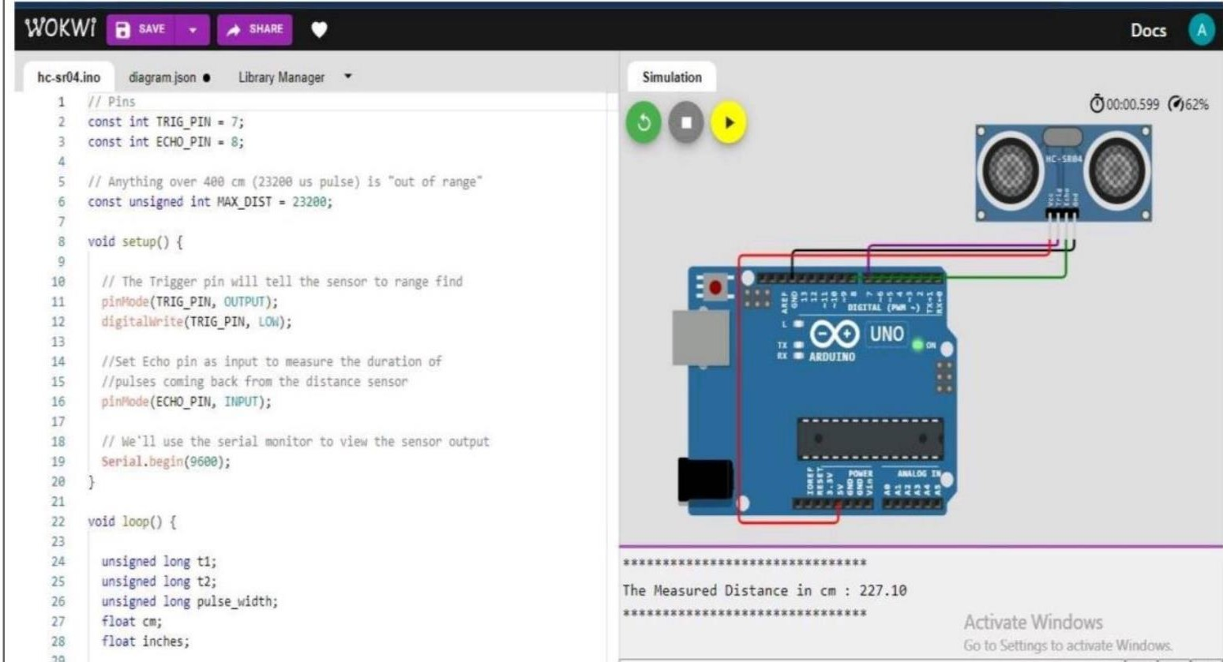

# Simulation and code execution

